Appendix A
Terrorism Incident Annex to the Federal Response Plan

Terrorism

Incident Annex

Signatory Agencies: Department of Defense
Department of Energy
Department of Health and Human Services
Department of Justice
Federal Bureau of Investigation
Environmental Protection Agency
Federal Emergency Management Agency

I. Introduction

Presidential Decision Directive 39 (PDD-39), U.S. Policy on Counterterrorism, establishes policy to reduce the Nation's vulnerability to terrorism, deter and respond to terrorism, and strengthen capabilities to detect, prevent, defeat, and manage the consequences of terrorist use of weapons of mass destruction (WMD). PDD-39 states that the United States will have the ability to respond rapidly and decisively to terrorism directed against Americans wherever it occurs, arrest or defeat the perpetrators using all appropriate instruments against the sponsoring organizations and governments, and provide recovery relief to victims, as permitted by law.

Responding to terrorism involves instruments that provide crisis management and consequence management. "Crisis management" refers to measures to identify, acquire, and plan the use of resources needed to anticipate, prevent, and/or resolve a threat or act of terrorism. The Federal Government exercises primary authority to prevent, preempt, and terminate threats or acts of terrorism and to apprehend and prosecute the perpetrators; State and local governments provide assistance as required. Crisis management is predominantly a law enforcement response. "Consequence management" refers to measures to protect public health and safety, restore essential government services, and provide emergency relief to governments, businesses, and individuals affected by the consequences of terrorism. State and local governments exercise primary authority to respond to the consequences of terrorism; the Federal Government provides assistance as required. Consequence management is generally a multifunction response coordinated by emergency management.

Based on the situation, a Federal crisis management response may be supported by technical operations, and by Federal consequence management, which may operate concurrently (see Figure TI-1). "Technical operations" includes actions to identify, assess, dismantle, transfer, dispose of, or decontaminate personnel and property exposed to explosive ordinance or WMD.

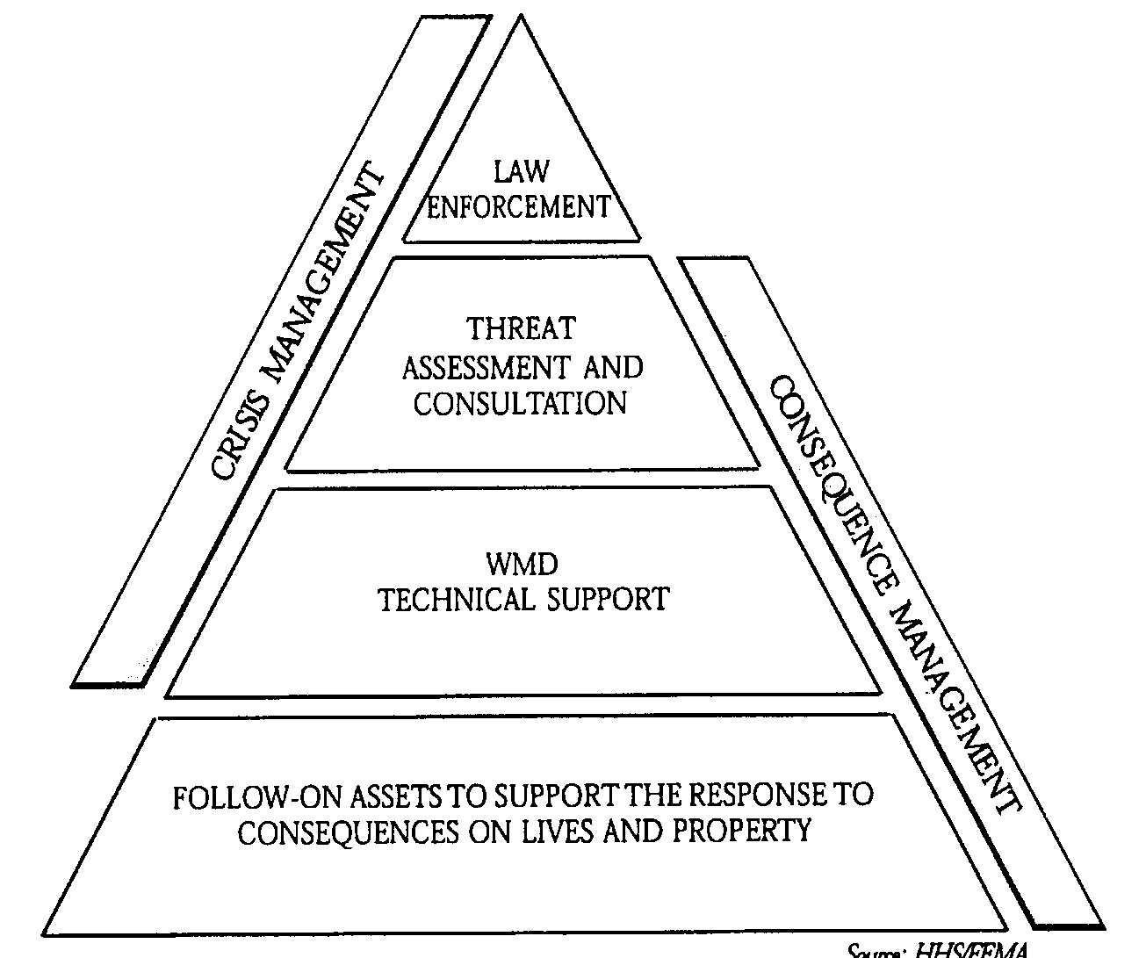

Figure TI-1 - Relationship Between Crisis Management and Consequence Management

A. Purpose

The purpose of this annex is to ensure that the Federal Response Plan (FRP) is adequate to respond to the consequences of terrorism within the United States, including terrorism involving WMD. This annex:

1. Describes crisis management. Guidance is provided in other Federal emergency operations plans;

2. Defines the policies and structures to coordinate crisis management with consequence management; and

3. Defines consequence management, which uses the FRP process and structure, supplemented as necessary by resources normally activated through other Federal emergency operations plans.

B. Scope

This annex:

1. Applies to all threats or acts of terrorism within the United States that the White House determines require a response under the FRP;
2. Applies to all Federal departments and agencies that may be directed to respond to the consequences of a threat or act of terrorism within the United States; and

3. Builds upon the process and structure of the FRP by addressing unique policies, situations, operating concepts, responsibilities, and funding guidelines required for response to the consequences of terrorism.

II. Policies

A. PDD-39 validates and reaffirms existing lead agency responsibilities for all facets of the U.S. counterterrorism effort.

B. The Department of Justice is designated as the lead agency for threats or acts of terrorism within U.S. territory. The Department of Justice assigns lead responsibility for operational response to the Federal Bureau of Investigation (FBI). Within that role, the FBI operates as the on-scene manager for the Federal Government. It is FBI policy that crisis management will involve only those Federal agencies requested by the FBI to provide expert guidance and/or assistance, as described in the PDD-39 Domestic Deployment Guidelines (classified) and the FBI WMD Incident Contingency Plan.

C. The Federal Emergency Management Agency (FEMA) is designated as the lead agency for consequence management within U.S. territory. FEMA retains authority and responsibility to act as the lead agency for consequence management throughout the Federal response. It is FEMA policy to use FRP structures to coordinate all Federal assistance to State and local governments for consequence management.

D. To ensure that there is one overall Lead Federal Agency (LFA), PDD-39 directs FEMA to support the Department of Justice (as delegated to the FBI) until the Attorney General transfers the overall LFA role to FEMA. FEMA supports the overall LFA as permitted by law.

III. Situation

A. Conditions

1. FBI assessment of a potential or credible threat of terrorism within the United States may cause the FBI to direct other members of the law enforcement community and to coordinate with other Federal agencies to implement a pre-release response.

a. FBI requirements for assistance from other Federal agencies will be coordinated through the Attorney General and the President, with coordination of National Security Council (NSC) groups as warranted.

b. FEMA will advise and assist the FBI and coordinate with the affected State and local emergency management authorities to identify potential consequence management requirements and with Federal consequence management agencies to increase readiness.
2. An act that occurs without warning and produces major consequences may cause FEMA to implement a post-release consequence management response under the FRP. FEMA will exercise its authorities and provide concurrent support to the FBI as appropriate to the specific incident.

B. Planning Assumptions

1. No single agency at the local, State, Federal, or private-sector level possesses the authority and expertise to act unilaterally on many difficult issues that may arise in response to a threat or act of terrorism, particularly if WMD are involved.

2. An act of terrorism, particularly an act directed against a large population center within the United States involving WMD, may produce major consequences that would overwhelm the capabilities of many local and State governments almost immediately.

3. Major consequences involving WMD may overwhelm existing Federal capabilities as well, particularly if multiple locations are affected.

4. Local, State, and Federal responders will define working perimeters that may overlap. Perimeters may be used to control access to the area, target public information messages, assign operational sectors among responding organizations, and assess potential effects on the population and the environment. Control of these perimeters may be enforced by different authorities, which will impede the overall response if adequate coordination is not established.

5. If appropriate personal protective equipment is not available, entry into a contaminated area (i.e., a hot zone) may be delayed until the material dissipates to levels that are safe for emergency response personnel. Responders should be prepared for secondary devices.

6. Operations may involve geographic areas in a single State or multiple States, involving responsible FBI Field Offices and Regional Offices as appropriate. The FBI and FEMA will establish coordination relationships as appropriate, based on the geographic areas involved.

7. Operations may involve geographic areas that spread across U.S. boundaries. The Department of State is responsible for coordination with foreign governments.

IV. Concept of Operations

A. Crisis Management

(Source: FBI, National Security Division, Domestic Terrorism/Counterterrorism Planning Section)

1. PDD-39 reaffirms the FBI's Federal lead responsibility for crisis management response to threats or acts of terrorism that take place within U.S. territory or in international waters and that do not involve the flag vessel of a foreign country. The FBI provides a graduated, flexible response to a range of incidents, including:

a. A credible threat, which may be presented in verbal, written, intelligence-based, or other form;
b. An act of terrorism that exceeds the local FBI field division's capability to resolve;

c. The confirmed presence of an explosive device or WMD capable of causing a significant destructive event, prior to actual injury or property loss;

d. The detonation of an explosive device, utilization of a WMD, or other destructive event, with or without warning, that results in limited injury or death; and

e. The detonation of an explosive device, utilization of a WMD, or other destructive event, with or without warning, that results in substantial injury or death.

2. The FBI notifies FEMA and other Federal agencies providing direct support to the FBI of a credible threat of terrorism. The FBI initiates a threat assessment process that involves close coordination with Federal agencies with technical expertise, in order to determine the viability of the threat from a technical as well as tactical and behavioral standpoints.

3. The FBI provides initial notification to law enforcement authorities within the affected State of a threat or occurrence that the FBI confirms as an act of terrorism.

4. If warranted, the FBI implements an FBI response and simultaneously advises the Attorney General, who notifies the President and NSC groups as warranted, that a Federal crisis management response is required. If authorized, the FBI activates multiagency crisis management structures at FBI Headquarters, the responsible FBI Field Office, and the incident scene (see Figure TI-2). Federal agencies requested by the FBI, including FEMA, will deploy a representative(s)

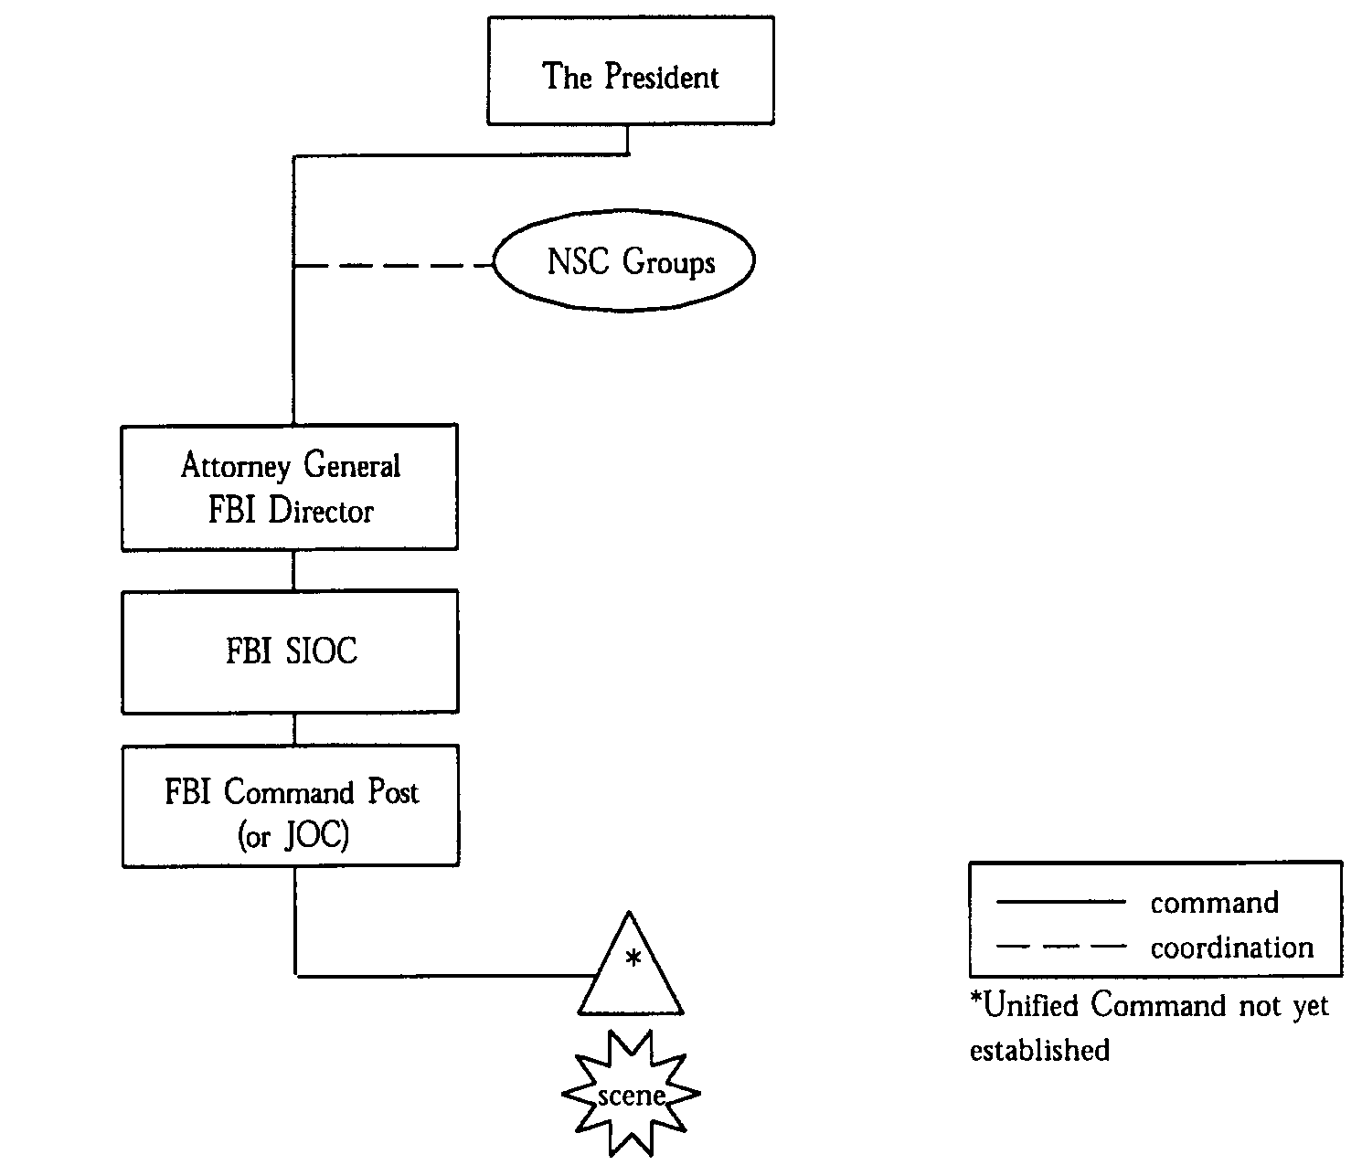
Figure TI-2 - Crisis Management Structures
to the FBI Headquarters Strategic Information and Operations Center (SIOC) and take other actions as necessary and appropriate to support crisis management. (The FBI provides guidance on the crisis management response in the FBI WMD Incident Contingency Plan.)

5. If the threat involves WMD, the FBI Director may recommend to the Attorney General, who notifies the President and NSC groups as warranted, to deploy a Domestic Emergency Support Team (DEST). The mission of the DEST is to provide expert advice and assistance to the FBI On-Scene Commander (OSC) related to the capabilities of the DEST agencies and to coordinate follow-on response assets. When a Joint Operations Center (JOC) is formed, DEST components merge into the JOC structure as appropriate. (The FBI provides guidance on the DEST in the PDD-39 Domestic Deployment Guidelines (classified).)

6. During crisis management, the FBI coordinates closely with local law enforcement authorities to provide a successful law enforcement resolution to the incident. The FBI also coordinates with other Federal authorities, including FEMA.

7. The FBI Field Office responsible for the incident site modifies its Command Post to function as a JOC and establishes a Joint Information Center (JIC). The JOC structure includes the following standard groups: Command, Operations, Support, and Consequence Management. Representation within the JOC includes some Federal, State, and local agencies (see Figure TI-3).

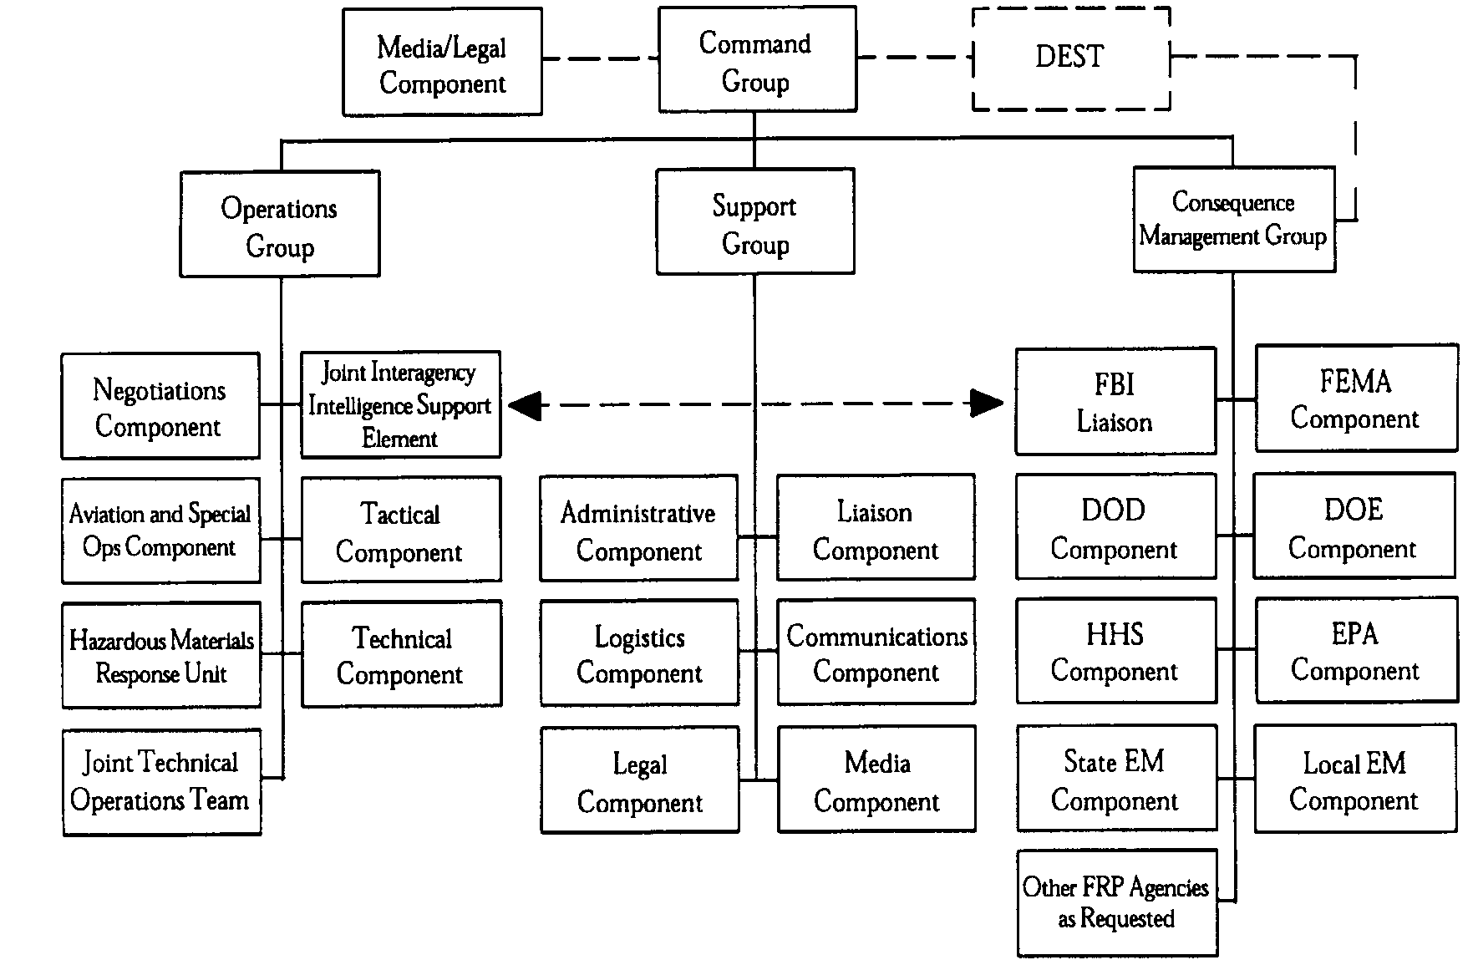
Figure TI-3 - FBI Joint Operations Center Structure
8. The JOC Command Group plays an important role in ensuring coordination of Federal crisis management and consequence management actions. Issues arising from the response that affect multiple agency authorities and responsibilities will be addressed by the FBI OSC and the other members of the JOC Command Group, who are all working in consultation with other local, State, and Federal representatives. While the FBI OSC retains authority to make Federal crisis management decisions at all times, operational decisions are made cooperatively to the greatest extent possible. The FBI OSC and the Senior FEMA Official at the JOC will provide, or obtain from higher authority, an immediate resolution of conflicts in priorities for allocation of critical Federal resources (such as airlift or technical operations assets) between the crisis management and the consequence management response.

9. A FEMA representative coordinates the actions of the JOC Consequence Management Group, expedites activation of a Federal consequence management response should it become necessary, and works with an FBI representative who serves as the liaison between the Consequence Management Group and the FBI OSC. The JOC Consequence Management Group monitors the crisis management response in order to advise on decisions that may have implications for consequence management, and to provide continuity should a Federal consequence management response become necessary. Coordination will also be achieved through the exchange of operational reports on the incident. Because reports prepared by the FBI are "law enforcement sensitive," FEMA representatives with access to the reports will review them, according to standard procedure, in order to identify and forward information to Emergency Support Function (ESF) #5 - Information and Planning that may affect operational priorities and action plans for consequence management.

B. Consequence Management

1. Pre-Release

a. FEMA receives initial notification from the FBI of a credible threat of terrorism. Based on the circumstances, FEMA Headquarters and the responsible FEMA region(s) may implement a standard procedure to alert involved FEMA officials and Federal agencies supporting consequence management.

b. FEMA deploys representatives with the DEST and deploys additional staff for the JOC, as required, in order to provide support to the FBI regarding consequence management. FEMA determines the appropriate agencies to staff the JOC Consequence Management Group and advises the FBI. With FBI concurrence, FEMA notifies consequence management agencies to request that they deploy representatives to the JOC. Representatives may be requested for the JOC Command Group, the JOC Consequence Management Group, and the JIC.

c. When warranted, FEMA will consult immediately with the Governor's office and the White House in order to determine if Federal assistance is required and if FEMA is permitted to use authorities of the Robert T. Stafford Disaster Relief and Emergency Assistance Act to mission-assign Federal consequence management agencies to pre-deploy assets to lessen or avert the threat of a catastrophe. These actions will involve appropriate notification and coordination with the FBI, as the overall LFA.

d. FEMA Headquarters may activate an Emergency Support Team (EST) and may convene an executive-level meeting of the Catastrophic Disaster Response Group (CDRG). When FEMA activates the EST, FEMA will request FBI Headquarters to provide liaison. The responsible FEMA region(s) may activate a Regional Operations Center (ROC) and deploy a representative(s) to the affected State(s). When the responsible FEMA region(s) activates a ROC, the region(s) will notify the responsible FBI Field Office(s) to request a liaison.

2. Post-Release

a. If an incident involves a transition from joint (crisis/consequence) response to a threat of terrorism to joint response to an act of terrorism, then consequence management agencies providing advice and assistance at the JOC pre-release will reduce their presence at the JOC post-release as necessary to fulfill their consequence management responsibilities. The Senior FEMA Official and staff will remain at the JOC until the FBI and FEMA agree that liaison is no longer required.

b. If an incident occurs without warning that produces major consequences and appears to be caused by an act of terrorism, then FEMA and the FBI will initiate consequence management and crisis management actions concurrently. FEMA will consult immediately with the Governor's office and the White House to determine if Federal assistance is required and if FEMA is permitted to use the authorities of the Stafford Act to mission-assign Federal agencies to support a consequence management response. If the President directs FEMA to implement a Federal consequence management response, then FEMA will support the FBI as required and will lead a concurrent Federal consequence management response (see Figure TI-4).

c. The overall LFA (either the FBI or FEMA when the Attorney General transfers the overall LFA role to FEMA) will establish a Joint Information Center in the field, under the operational control of the overall LFA's Public Information Officer, as the focal point for the coordination and provision of information to the public and media concerning the Federal response to the emergency. Throughout the response, agencies will continue to coordinate incident-related information through the JIC. FEMA and the FBI will ensure that appropriate spokespersons provide information concerning the crisis management and consequenct management responses. Before a JIC is activated, public affairs offices of responding Federal agencies will coordinate the release of information through the FBI SIOC.
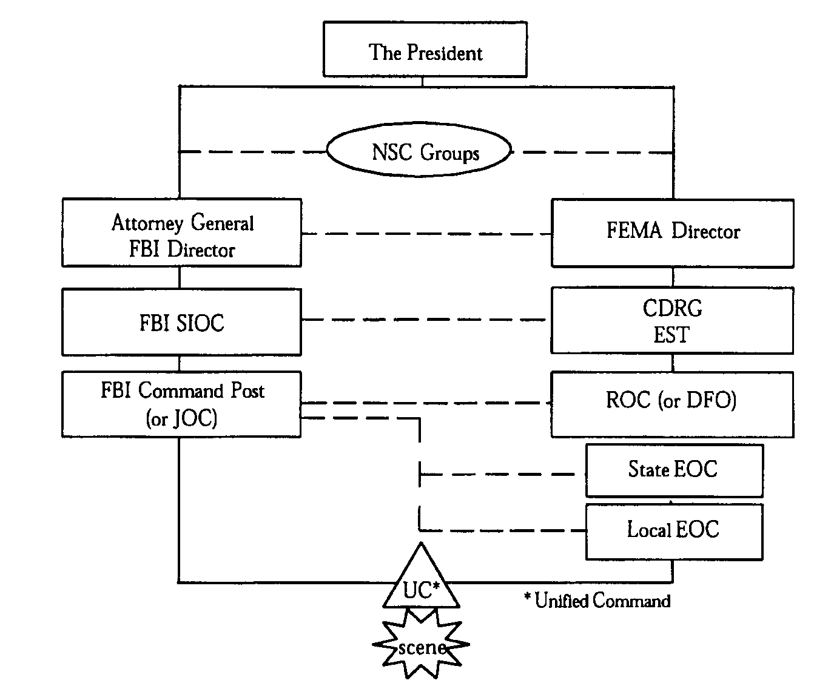

Figure TI-4 - Coordination Relationships

d. During the consequence management response, the FBI provides liaison to either the ROC Director or the Federal Coordinating Officer (FCO) in the field, and a liaison to the EST Director at FEMA Headquarters. While the ROC Director or FCO retains authority to make Federal consequence management decisions at all times, operational decisions are made cooperatively to the greatest extent possible.

e. As described previously, resolution of conflicts between the crisis management and consequence management responses will be provided by the Senior FEMA Official and the FBI OSC at the JOC or, as necessary, will be obtained from higher authority. Operational reports will continue to be exchanged. The FBI liaisons will remain at the EST and the ROC or DFO until FEMA and the FBI agree that a liaison is no longer required.

3. Disengagement

a. If an act of terrorism does not occur, the consequence management response disengages when the FEMA Director, in consultation with the FBI Director, directs FEMA Headquarters and the responsible region(s) to issue a cancellation notification by standard procedure to appropriate FEMA officials and FRP agencies. FRP agencies disengage according to standard procedure.

b. If an act of terrorism occurs that results in major consequences, each FRP component (the EST, CDRG, ROC, and DFO if necessary) disengages at the appropriate time according to standard procedure. Following FRP
disengagement, operations by individual Federal agencies or by multiple Federal agencies under other Federal plans may continue, in order to support the affected State and local governments with long-term hazard monitoring, environmental decontamination, and site restoration (cleanup).

V. Responsibilities

A. Department of Justice

PDD-39 validates and reaffirms existing lead agency responsibilities for all facets of the U.S. counterterrorism effort. The Department of Justice is designated as the overall LFA for threats of acts of terrorism that take place within the United States until the Attorney General transfers the overall LFA role to FEMA. The Department of Justice delegates this overall LFA role to the FBI for the operational response. On behalf of the Department of Justice, the FBI will:

1. Consult with and advise the White House, through the Attorney General, on policy matters concerning the overall response;

2. Designate and establish a JOC in the field;

3. Appoint an FBI OSC to manage and coordinate the Federal operational response (crisis management and consequence management). As necessary, the FBI OSC will convene and chair meetings of operational decision makers representing lead State and local crisis management agencies, FEMA, and lead State and local consequence management agencies in order to provide an initial assessment of the situation, develop an action plan, monitor and update operational priorities, and ensure that the overall response (crisis management and consequence management) is consistent with U.S. law and achieves the policy objectives outlined in PDD-39. The FBI and FEMA may involve supporting Federal agencies as necessary; and

4. Issue and track the status of actions assigned by the overall LFA.

B. Federal Bureau of Investigation

Under PDD-39, the FBI supports the overall LFA by operating as the lead agency for crisis management. The FBI will:

1. Determine when a threat of an act of terrorism warrants consultation with the White House, through the Attorney General;

2. Advise the White House, through the Attorney General, when the FBI requires assistance for a Federal crisis management response, in accordance with the PDD-39 Domestic Deployment Guidelines;

3. Work with FEMA to establish and operate a JIC in the field as the focal point for information to the public and the media concerning the Federal response to the emergency;

4. Establish the primary Federal operations centers for the crisis management response in the field and Washington, DC;
5. Appoint an FBI OSC (or subordinate official) to manage and coordinate the crisis management response. Within this role, the FBI OSC will convene meetings with operational decision makers representing Federal, State, and local law enforcement and technical support agencies, as appropriate, to formulate incident action plans, define priorities, review status, resolve conflicts, identify issues that require decisions from higher authorities, and evaluate the need for additional resources;

6. Issue and track the status of crisis management actions assigned by the FBI; and

7. Designate appropriate liaison and advisory personnel to support FEMA.

C. Federal Emergency Management Agency

Under PDD-39, FEMA supports the overall LFA by operating as the lead agency for consequence management until the overall LFA role is transferred to FEMA. FEMA will:

1. Determine when consequences are "imminent" for the purposes of the Stafford Act;

2. Consult with the Governor's office and the White House to determine if a Federal consequence management response is required and if FEMA is directed to use Stafford Act authorities. This process will involve appropriate notification and coordination with the FBI, as the overall LFA;

3. Work with the FBI to establish and operate a JIC in the field as the focal point for information to the public and the media concerning the Federal response to the emergency;

4. Establish the primary Federal operations centers for consequence management in the field and Washington, DC;

5. Appoint a ROC Director or FCO to manage and coordinate the Federal consequence management response in support of State and local governments. In coordination with the FBI, the ROC Director or FCO will convene meetings with decision makers of Federal, State, and local emergency management and technical support agencies, as appropriate, to formulate incident action plans, define priorities, review status, resolve conflicts, identify issues that require decisions from higher authorities, and evaluate the need for additional resources;

6. Issue and track the status of consequence management actions assigned by FEMA; and

7. Designate appropriate liaison advisory personnel to support the FBI.

D. Federal Agencies Supporting Technical Operations

1. Department of Defense

As directed in PDD-39, the Department of Defense (DOD) will activate technical operations capabilities to support the Federal response to threats or acts of WMD terrorism. DOD will coordinate military operations within the United States with the appropriate civilian lead agency(ies) for technical operations.
2. Department of Energy

As directed in PDD-39, the Department of Energy (DOE) will activate technical operations capabilities to support the Federal response to threats or acts of WMD terrorism. In addition, the FBI has concluded formal agreements with potential LFAs of the Federal Radiological Emergency Response Plan (FRERP) that provide for interface, coordination, and technical assistance in support of the FBI's mission. If the FRERP is implemented concurrently with the FRP:

a. The Federal On-Scene Commander under the FRERP will coordinate the FRERP response with the FEMA official (either the ROC Director or the FCO), who is responsible under PDD-39 for coordination of all Federal support to State and local governments.

b. The FRERP response may include on-site management, radiological monitoring and assessment, development of Federal protective action recommendations, and provision of information on the radiological response to the public, the White House, Members of Congress, and foreign governments. The LFA of the FRERP will serve as the primary Federal source of information regarding on-site radiological conditions and off-site radiological effects.

c. The LFA of the FRERP will issue taskings that draw upon funding from the responding FRERP agencies.

3. Department of Health and Human Services

As directed in PDD-39, the Department of Health and Human Services (HHS) will activate technical operations capabilities to support the Federal response to threats or acts of WMD terrorism. HHS may coordinate with individual agencies identified in the HHS Health and Medical Services Support Plan for the Federal Response to Acts of Chemical/Biological (C/B) Terrorism, to use the structure, relationships, and capabilities described in the HHS plan to support response operations. If the HHS plan is implemented:

a. The HHS on-scene representative will coordinate, through the ESF #8 -- Health and Medical Services Leader, the HHS plan response with the FEMA official (either the ROC Director or the FCO), who is responsible under PDD-39 for on-scene coordination of all Federal support to State and local governments.

b. The HHS plan response may include threat assessment, consultation, agent identification, epidemiological investigation, hazard detection and reduction, decontamination, public health support, medical support, and pharmaceutical support operations.

c. HHS will issue taskings that draw upon funding from the responding HHS plan agencies.
4. Environmental Protection Agency

As directed in PDD-39, the Environmental Protection Agency (EPA) will activate technical operations capabilities to support the Federal response to acts of WMD terrorism. EPA may coordinate with individual agencies identified in the National Oil and Hazardous Substances Pollution Contingency Plan (NCP) to use the structure, relationships, and capabilities of the National Response System as described in the NCP to support response operations. If the NCP is implemented:

a. The Hazardous Materials On-Scene Coordinator under the NCP will coordinate, through the ESF #10 - Hazardous Materials Chair, the NCP response with the FEMA official (either the ROC Director or the FCO), who is responsible under PDD-39 for on-scene coordination of all Federal support to State and local governments.

b. The NCP response may include threat assessment, consultation, agent identification, hazard detection and reduction, environmental monitoring, decontamination, and long-term site restoration (environmental cleanup) operations.

VI. Funding Guidelines

A. As stated in PDD-39, Federal agencies directed to participate in the resolution of terrorist incidents or conduct of counterterrorist operations bear the costs of their own participation, unless otherwise directed by the President. This responsibility is subject to specific statutory authorization to provide support without reimbursement. In the absence of such specific authority, the Economy Act applies, and reimbursement cannot be waived.

B. FEMA can use limited pre-deployment authorities in advance of a Stafford Act declaration to "lessen or avert the threat of a catastrophe" only if the President expresses intention to go forward with a declaration. This authority is further interpreted by congressional intent, to the effect that the President must determine that assistance under existing Federal programs is inadequate to meet the crisis, before FEMA may directly intervene under the Stafford Act. The Stafford Act authorizes the President to issue "emergency" and "major disaster" declarations.

1. Emergency declarations may be issued in response to a Governor's request, or in response to those rare emergencies, including some acts of terrorism, for which the Federal Government is assigned in the laws of the United States the exclusive or preeminent responsibility and authority to respond.

2. Major disaster declarations may be issued in response to a Governor's request for any natural catastrophe or, regardless of cause, any fire, flood, or explosion that has caused damage of sufficient severity and magnitude, as determined by the President, to warrant major disaster assistance under the Act.

3. If a Stafford Act declaration is provided, funding for consequence management may continue to be allocated from responding agency operating budgets, the Disaster Relief Fund, and supplemental appropriations.
C. If the President directs FEMA to use Stafford Act authorities, FEMA will issue mission assignments through the FRP to support consequence management.

1. Mission assignments are reimbursable work orders, issued by FEMA to Federal agencies, directing completion of specific tasks. Although the Stafford Act states that "Federal agencies may [emphasis added] be reimbursed for expenditures under the Act" from the Disaster Relief Fund, it is FEMA policy to reimburse Federal agencies for eligible work performed under mission assignments.

2. Mission assignments issued to support consequence management will follow FEMA's Standard Operating Procedures for the Management of Mission Assignments or applicable superseding documentation.

D. FEMA provides the following funding guidance to the FRP agencies:

1. Commitments by individual agencies to take precautionary measures in anticipation of special events will not be reimbursed under the Stafford Act, unless mission-assigned by FEMA to support consequence management.

2. Stafford Act authorities do not pertain to law enforcement functions. Law enforcement or crisis management actions will not be mission-assigned for reimbursement under the Stafford Act.

VII. References

A. Presidential Decision Directive 39, U.S. Policy on Counterterrorism (classified). An unclassified extract may be obtained from FEMA.

B. PDD-39 Domestic Deployment Guidelines (classified).

C. PDD-62, Protection Against Unconventional Threats to the Homeland and Americans Overseas (classified).

D. FBI WMD Incident Contingency Plan.

E. HHS Health and Medical Services Support Plan for the Federal Response to Acts of Chemical/Biological Terrorism.

VIII. Terms and Definitions

A. Biological Agents

The FBI WMD Incident Contingency Plan defines biological agents as microorganisms or toxins from living organisms that have infectious or noninfectious properties that produce lethal or serious effects in plants and animals.

B. Chemical Agents

The FBI WMD Incident Contingency Plan defines chemical agents as solids, liquids, or gases that have chemical properties that produce lethal or serious effects in plants and animals.
C. Consequence Management

FEMA defines consequence management as measures to protect public health and safety, restore essential government services, and provide emergency relief to governments, businesses, and individuals affected by the consequences of terrorism.

D. Credible Threat

The FBI conducts an interagency threat assessment that indicates that the threat is credible and confirms the involvement of a WMD in the developing terrorist incident.

E. Crisis Management

The FBI defines crisis management as measures to identify, acquire, and plan the use of resources needed to anticipate, prevent, and/or resolve a threat or act of terrorism.

F. Domestic Emergency Support Team (DEST)

PDD-39 defines the DEST as a rapidly deployable interagency support team established to ensure that the full range of necessary expertise and capabilities are available to the on-scene coordinator. The FBI is responsible for the DEST in domestic incidents.

G. Lead Agency

The FBI defines lead agency, as used in PDD-39, as the Federal department or agency assigned lead responsibility to manage and coordinate a specific function--either crisis management or consequence management. Lead agencies are designated on the basis of their having the most authorities, resources, capabilities, or expertise relative to accomplishment of the specific function. Lead agencies support the overall Lead Federal Agency during all phases of the terrorism response.

H. Nuclear Weapons

The Effects of Nuclear Weapons (DOE, 1977) defines nuclear weapons as weapons that release nuclear energy in an explosive manner as the result of nuclear chain reactions involving fission and/or fusion of atomic nuclei.

I. Senior FEMA Official

The official appointed by the Director of FEMA or his representative to represent FEMA on the Command Group at the Joint Operations Center. The Senior FEMA Official is not the Federal Coordinating Officer.

J. Technical Operations

As used in this annex, technical operations include actions to identify, assess, dismantle, transfer, dispose of, or decontaminate personnel and property exposed to explosive ordnance or WMD.
K. Terrorist Incident

The FBI defines a terrorist incident as a violent act, or an act dangerous to human life, in violation of the criminal laws of the United States or of any State, to intimidate or coerce a government, the civilian population, or any segment thereof in furtherance of political or social objectives.

L. Weapon of Mass Destruction (WMD)

Title 18, U.S.C. 2332a, defines a weapon of mass destruction as (1) any destructive device as defined in section 921 of this title, [which reads] any explosive, incendiary, or poison gas, bomb, grenade, rocket having a propellant charge of more than four ounces, missile having an explosive or incendiary charge of more than one-quarter ounce, mine or device similar to the above; (2) poison gas; (3) any weapon involving a disease organism; or (4) any weapon that is designed to release radiation or radioactivity at a level dangerous to human life.

Appendix b
Presidential decision directive 39 (unclassified)

The following is a copy of an unclassified* abstrct derived from Presidential Decision Directive 39 (PDD-39), United States Policy on Counterterrorism, dated June 21, 1995. This abstract has been reviewed and approved by the National Secutreity Council (NSC) for distribution to Federal, State, and local emergency response and consequence management personnel to assist them in responding to terrorist emergencies.

*The full text of PDD-39 is a CLASSIFIED document. State and local officals, however, should understand that PDD-39 essentially gives the responsibility of response to terrorist attacks to the FBI for "crisis management" and FEMA for "consequence managmenent." State and local agencies and assets will be expected to support the Federal efforts.

UNITED STATES POLICY ON COUNTERTERRORISM

- General. Terrorism is both a threat to our national security as well as a criminal act. The Administration has stated that it is the policy of the United States to use all appropriate means to deter, defeat and respond to all terrorist attacks on our territory and resources, both people and facilities, wherever they occur. In support of these efforts, the United States will:

- Employ efforts to deter, preempt, apprehend and prosecute terrorists.

- Work closely with other governments to carry out our counterterrorism policy and combat terrorist threats against them.

- Identify sponsors of terrorists, isolate them, and ensure they pay for their actions.

- Make no concessions to terrorists.

- Measures to Combat Terrorism. To ensure that the United States is prepared to combat terrorism in all its forms, a number of measures have been directed. These include reducing vulnerabilities to terrorism, deterring and responding to terrorist acts, and having capabilities to prevent and manage the consequences of terrorist use of nuclear, biological, and chemical (NBC) weapons, including those of mass destruction.

- Reduce Vulnerabilities. In order to reduce our vulnerabilities to terrorism, both at home and abroad, all department/agency heads have been directed to ensure that their personnel and facilities are fully protected against terrorism. Specific efforts that will be conducted to ensure our security against terrorist acts include the following:

- Review the vulnerability of government facilities and critical national infrastructure.

- Expand the program of counterterrorism.

- Reduce vulnerabilities affecting civilian personnel/facilities abroad and military personnel/facilities.

- Reduce vulnerabilities affecting U.S. airports, aircraft/passengers and shipping, and provide appropriate security measures for other modes of transportation.

- Exclude/deport persons who pose a terrorist threat.

- Prevent unlawful traffic in firearms and explosives, and protect the President and other officials against terrorist attack.

- Reduce U.S. vulnerabilities to international terrorism through intelligence collection/analysis, counterintelligence and covert action.

- Deter. To deter terrorism, it is necessary to provide a clear public position that our policies will not be affected by terrorist acts and we will vigorously deal with terrorist/sponsors to reduce terrorist capabilities and support. In this regard, we must make it clear that we will not allow terrorism to succeed and that the pursuit, arrest, and prosecution of terrorists is of the highest priority. Our goals include the disruption of terrorist-sponsored activity including termination of financial support, arrest and punishment of terrorists as criminals, application of U.S. laws and new legislation to prevent terrorist groups from operating in the United States, and application of extraterritorial statutes to counter acts of terrorism and apprehend terrorists outside of the United States. Return of terrorists overseas, who are wanted for violation of U.S. law, is of the highest priority and a central issue in bilateral relations with any state that harbors or assists them.

- Respond. To respond to terrorism, we must have a rapid and decisive capability to protect Americans, defeat or arrest terrorists, respond against terrorist sponsors, and provide relief to the victims of terrorists. The goal during the immediate response phase of an incident is to terminate terrorist attacks so that the terrorists do not accomplish their objectives or maintain their freedom, while seeking to minimize damage and loss of life and provide emergency assistance. After an incident has occurred, a rapidly deployable interagency Emergency Support Team (EST) will provide required capabilities on scene: a Foreign Emergency Support Team (FEST) for foreign incidents and a Domestic Emergency Support Team (DEST) for domestic incidents. DEST membership will be limited to those agencies required to respond to the specific incident. Both teams will include elements for specific types of incidents such as nuclear, biological or chemical threats.

The Director, FEMA, will ensure that the Federal Response Plan is adequate for consequence management activities in response to terrorist attacks against large U.S. populations, including those where weapons of mass destruction are involved. FEMA will also ensure that State response plans and capabilities are adequate and tested. FEMA, supported by all Federal Response Plan signatories, will assume the Lead Agency role for consequence management in Washington, DC, and on scene. If large scale casualties and infrastructure damage occur, the President may appoint a Personal Representative for consequence management as the on scene Federal authority during recovery. A roster of senior and former government officials willing to perform these functions will be created and the rostered individuals will be provided training and information necessary to allow them to be called upon on short notice.

Agencies will bear the costs of their participation in terrorist incidents and counterterrorist operations, unless otherwise directed.

- NBC Consequence Management. The development of effective capabilities for preventing and managing the consequences of terrorist use of nuclear, biological or chemical (NBC) materials or weapons is of the highest priority. Terrorist acquisition of weapons of mass destruction is not acceptable and there is no higher priority than preventing the acquisition of such materials/weapons or removing this capability from terrorist groups. FEMA will review the Federal Response Plan on an urgent basis, in coordination with supporting agencies, to determine its adequacy in responding to an NBC-related terrorist incident; identify and remedy any shortfalls in stockpiles, capabilities or training; and report on the status of these efforts in 180 days.

Appendix c
Related Course List

The following National Fire Academy (NFA) and Emergency Management Institute (EMI) courses can assist fire and emergency services personnel in preparing for consequence management of terrorism incidents. Readiness for such occurrences is a logical extension of normal major incident preparation. These courses have components or modules that contribute to the development of skills, knowledge, and abilities of those who must be ready to respond to terrorist incidents.

Part I—National Fire Academy (NFA) Courses

Hazardous Materials

O234 Chemistry of Hazardous Materials
A two-week course that focuses on the basic knowledge required to evaluate the potential hazards and behaviors of materials considered to be hazardous.

R243 Hazardous Materials Incident Management
A six-day course that focuses on the duties and responsibilities of the emergency response personnel who will assume the Incident Commander (IC) role in hazardous materials emergencies.

R229 Hazardous Materials Operating Site Practices
A two-week course that focuses on the strategies and safe procedures for alleviating the danger at hazardous materials incidents.

F809 Initial Response to Hazardous Materials Incidents: Basic Concepts
A two-day course that gives students an understanding of the basic concepts and techniques of first response to hazardous materials incidents.

F808 Initial Response to Hazardous Materials Incidents: Concept Implementation
A two-day course that expands upon the above course. New concepts and more detail are provided on procedures, usage, and related considerations following the basic chronology of a hazardous materials incident.

Emergency Medical Services

R151 Advanced Leadership Issues in Emergency Medical Service
A two-week course designed for upper-management personnel who have organizational responsibility for emergency medical operations in their agency. Situational, scenario-based instruction is the foundation for this course.

R150 Management of Emergency Medical Services
A two-week course that focuses on current and emerging management practices as they relate to EMS in the fire service.

Emergency Medical Services/Hazardous Materials

R247 Advanced Life Support Response to Hazardous Materials Incidents
A two-week course that focuses on indepth chemistry, toxicology, and the medical management of victims for paramedic personnel.

F246 Basic Life Support and Hazardous Materials Response
A two-day course that focuses on critical concerns for emergency medical responders at hazardous materials incidents.

Safety

F719 Incident Safety Officer
A two-day course that focuses on the Safety Officer's role at emergency responses, specifically on the Safety Officer role within the Incident Command System (ICS). Response to all-hazard types of situations is emphasized.

F720 Health and Safety Officer
A two-day course that focuses on the Health and Safety Officer's role in identifying, evaluating, and implementing policy and procedures that affect health and safety aspects for first responders.

Command and Control

R306 Executive Analysis of Fire Service Operations in Emergency Management
A two-week course that is designed to prepare senior staff officers in the administrative functions necessary to manage the operational component of a fire and rescue department.

R304 Command and Control of Fire Department Operations at Multi-Alarm Incidents
A two-week course, using intensive simulation, that focuses on the command officer's responsibility while conducting major operations involving multialarm units.

R308 Command and Control of Fire Department Operations at Natural and Man-Made Disasters
A two-week course that focuses on fire and rescue department operations at natural and manmade disasters that may require interagency or inter-jurisdictional coordination.

R314 Command and Control of Fire Department Operations at Target Hazards
A six-day course designed to introduce command officers to the complexities involved in commanding incidents at high-risk areas.

R801 Fire Command Operations
A six-day course where volunteer fire officers are introduced to incident command and study proper fire command techniques for control and extinguishment of fires ranging from small, residential structures to multioccupancy, commercial complexes.

Managing Company Tactical Operations
A series of four two-day courses that focus on fire and rescue practices dealing with confinement, extinguishment, water supply, salvage, and offensive and defensive firefighting operations. Courses are divided into Preparation (F375), Decisionmaking (F450), Tactics (F451), and Simulation (no course number assigned).

Command and Control/Emergency Medical Services

F160 Incident Command System for Emergency Medical Services
A two-day course that focuses on the concepts of EMS-specific incident command using lecture, role play, simulation, case studies, and graphics.

Arson

R205 Fire/Arson Investigation
A two-week course that addresses the basic skills needed to conduct fire investigations. Students will be equipped to identify the origin and cause of fires, to conduct a technically and legally sound investigation, and to pursue the case through the judicial system.

R811 Fire Cause Determination for Company Officers
A six-day course that addresses the skills needed to conduct initial fire cause determinations.

R207 Management for Arson Prevention and Control
A two-week course that focuses on innovative concepts and practical skills for managing a synergistic response to arson prevention and control.

R216 Initial Fire Investigation
A six-day course that focuses on the needs of personnel whose duties include determining origin and cause, and responsibility for fires and explosions based primarily on examination of the incident scene.

Emergency Response to Terrorism

R817 Emergency Response to Terrorism: Incident Management
or
N817 This six-day course focuses on the unique aspects introduced into operations by the nature of terrorist events. It has a heavy planning emphasis and includes recognizing the outward warning signs and detection clues that a terrorist incident is in progress. The course primarily addresses the need of experienced incident commanders when planning a response to a terrorist incident. It anticipates that a terrrorist incident will greatly challenge the chief officer's ability to manage the incident safely and effectively.

R818 Emergency Response to Terrorism: Tactical Considerations
There are three two-day courses pertaining to tactical considerations for the company officer, emergency medical services and haz mat personnel. These courses are designed for the first on-the-scene responder from the fire service, having these responsibilities. Each course targets the specific responses needed to a biological, nuclear, incendiary, chemical or explosive attack.

W553 Emergency Response to Terrorism: Tactical Considerations--Hazardous Materials
This course deals with issues for first on-scene responding haz mat technicians or persons with responsibility for developing initial haz mat tactics. It uses exercises to apply knowledge about security considerations, identifying signs of terrorism, anticipating unusual response circumstances, assessing information and initiating self-protection actions.
W554 Emergency Response to Terrorism: Tactical Considerations--Emergency Medical Services
Learners will apply knowledge of a terrorist event, provide patient care, identify and preserve evidence, manage site safety, document the event and debrief personnel. Training also will deal with security considerations, identifying signs of terrorism, anticipating unusual response circumstances, assessing information and initiating self-protection actions.

W552 Emergency Response to Terrorism: Tactical Considerations--Company Officer
This course builds on the skills of the initial "first-on-scene" supervisor. Learners will be trained in security considerations, identifying signs of terrorism, anticipating unusual response circumstances, assessing information and initiating self-protection actions.

F531 Emergency Response to Terrorism: Basic Concepts
or
H531 This course prepares first responders to take appropriate actions, such as secure the scene, initiate self-protective measures, and notify appropriate agencies of a potential terrorist incident. It gives learners a general understanding and ability to recognize terrorist weapons that are biological, nuclear, incendiary, chemical, or explosive.

Degrees at a Distance

Disaster and Fire Defense Planning
A course offered through the NFA's Degrees at a Distance Program that focuses on the concepts and principles of community fire risk assessment, as related to group fires and disasters (no course number assigned).

Managerial Issues in Hazardous Materials
A course offered through the NFA's Degrees at a Distance Program that focuses on the issues that confront hazardous materials program managers, from planning to postincident phases (no course number assigned).

Part II--Emergency Management Institute (EMI) Courses

E417 Community Emergency Response Team (CERT) Train-the-Trainer Course
A two-and-a-half-day course conducted in residence at EMI prepares participants to institute a CERT program in their communities. Topics include fire suppression, disaster medical operations, light search and rescue, and team organization and management.

G357 Emergency Response to Criminal and Terrorist Incidents
A six-hour workshop course that sensitizes responders to the special issues involved in responding to an event that may involve a crime. Topics such as preservation of evidence are covered in detail.

G120 Exercise Design Course
A two-day course designed to enable participants to conduct community emergency management exercises to test the communities' emergency operations plans and to rehearse key response personnel.

G130 Exercise Evaluation Course
A two-day course that enables participants to manage exercise evaluation activities before, during, and following an exercise.

G191 Incident Command System (ICS)/Emergency Operations Center (EOC) Interface
A one-and-a-half-day field course designed for delivery to ICS and EOC personnel in a community. Course provides an opportunity to develop a working interface between the IC and the EOC. The course reviews ICS and EOC concepts and uses exercises to demonstrate key points.

G190 Incident Command System (ICS) for Law Enforcement Personnel
A 12-hour field course introduces police and other law enforcement personnel to ICS and provides opportunities for exercising the concepts learned.

G192 Incident Command System (ICS) for Public Works Officials
A one-and-a-half-day field course that introduces public works personnel to ICS and provides opportunities for exercising the concepts learned.

S105 Integrated Emergency Management Course (IEMC): Consequences of Terrorism
A five-day exercise-based course that focuses on preparing for, responding to, and recovering from the emergency consequences of a terrorist act. Special attention is placed on the response among agencies when the disaster area is also a crime scene.

Joint Information Center (JIC)/Joint Information System (JIS) Course
A 16 to 24-hour course that introduces participants to the JIC/JIS concept and details the functions to be performed in establishing a single location for the dissemination of coordinated emergency information.

G386 Mass Fatalities Incident Course
A one-week field course designed to prepare local and State response personnel and other involved personnel to manage incidents involving large numbers of fatalities effectively.

For More Information…

For more information on any of these courses, please contact the National Emergency Training Center at (800) 238-3358, or (301) 447-1000.

