Annex 4 –
List of Publications and Audiovisual Material Produced in 2005

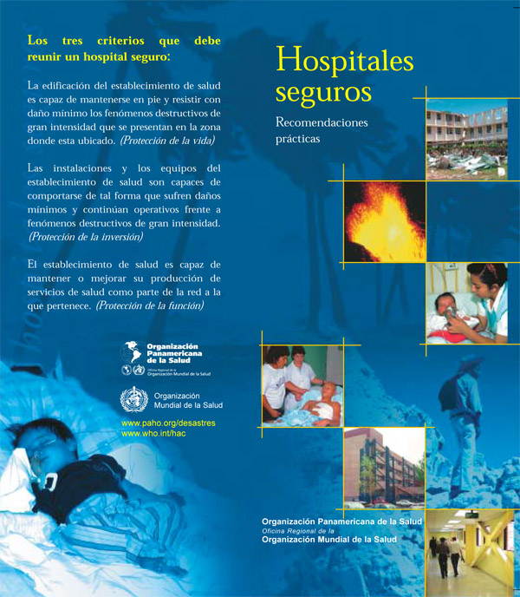 | Based on the success of the publication Safe Hospitals—A Collective Responsibility, A Global Measure of Disaster Reduction which deals with the protections of critical health facilities, particularly hospitals, from the avoidable consequences of disasters, a brochure was created in Spanish for distribution at meetings, condensing the information in the original publication.
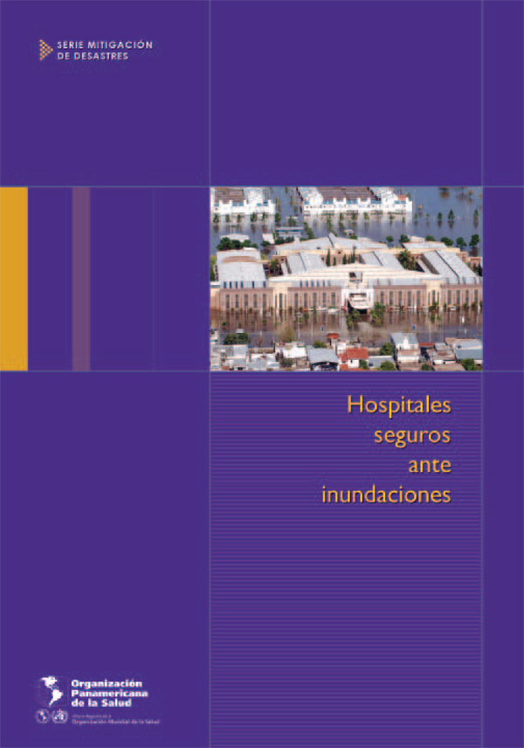 | Hospitals safe from floods (Hospitales seguros ante inundaciones)  This new publication looks at the most common health effects of floods. Additionaly, it provides technical recommendations to prevent, mitigate, retrofit and reconstruct vulnerable health infrastructure which are at risk or have been affected by floods. Not only will these interventions reduce the impact of a disaster, they will also improve the response, particularly in times of crises when hospitals are needed most. (in Spanish only).
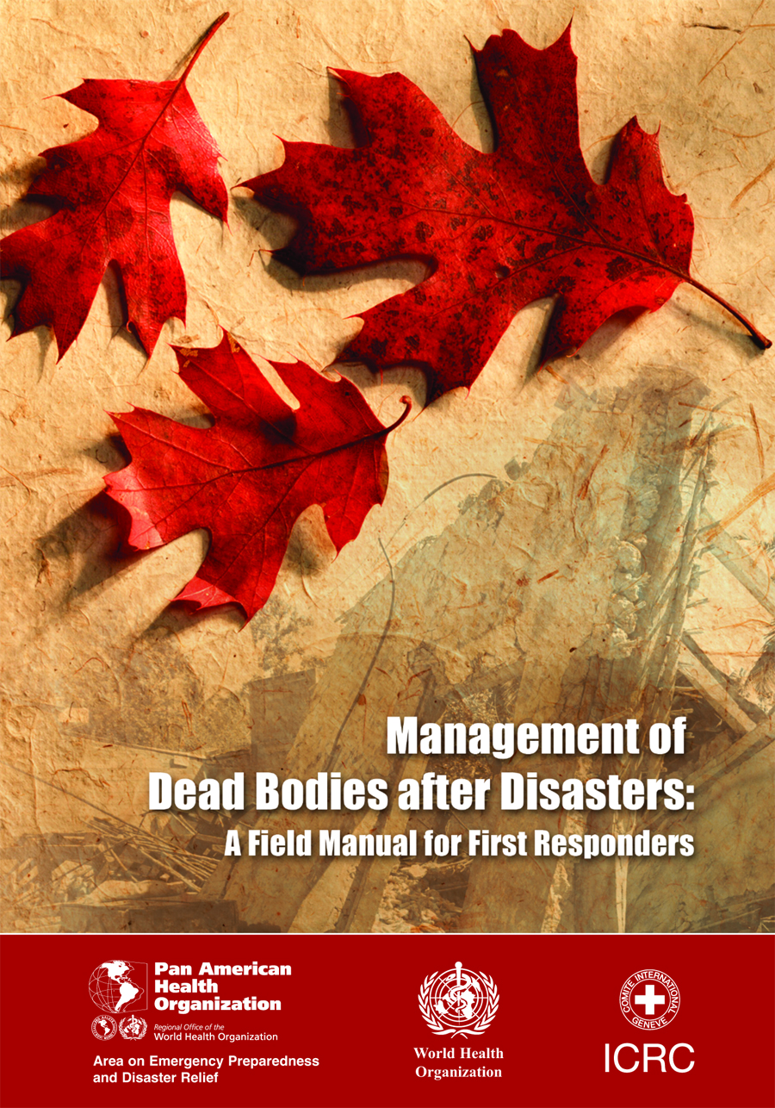 | Management of Dead Bodies alter Disasters: A Field Manual for First Responders  The objective of this guide—prepared for first responders—is the promotion of the dignified and appropriate management of cadavers in disaster situations, and their proper identification following practical and easy to follow procedures. It has been prepared by a group of international experts under the coordination of PAHO/WHO and the ICRC.
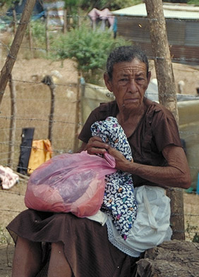 | Practical Guide for Mental Health in Disasters. Disaster Manuals and Guidelines No. 6 (Guía práctica de salud mental en desastres. Manual y Guía sobre Desastres No. 6)  These procedures help in the identification and management of the different psychosocial manifestations that can show up in disaster victims. It should help the work of health workers in these types of emergencies. The guide is available in Spanish only.
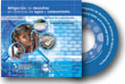 | Disaster mitigation in drinking water and sewerage systems  This CD-ROM contains an assortment of training and dissemination material on disaster mitigation in water and sanitation systems. An effort has been made to assemble or create the most effective material, including a slideshow and a compilation of technical papers on the subject that describe the theoretical and practical aspects of vulnerability assessment and introduce basic mitigation measures that can be taken in response to each of the natural hazards common in Latin America and the Caribbean. It is also available on the web.

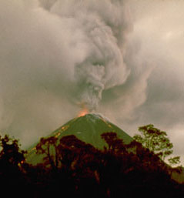 | Simulación erupciones volcánicas. CDROM  A multimedia software has been developed to enable health Emergency Operations Centers (EOC) to conduct simulation exercises. This simulation software has advantages over traditional paper-based exercises in that the computer interface, with video images, radio spots, photos, written reports and other documentation, immerses the user in a situation that is as close-to-reality as possible. Participants are forced to interpret and act on a large volume of information, both qualitative and quantitative. They can then measure the results, negotiate and discuss their decisions.
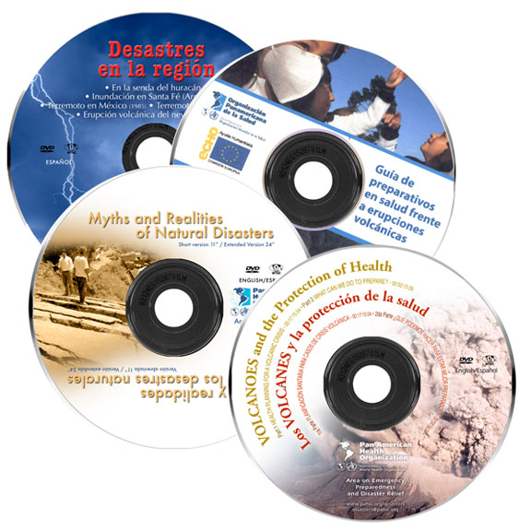 | Disaster Videos Now Available in DVD format  The PAHO/WHO video library includes historic footage and edited documentaries on many major disasters of the 1980s and 1990s as well as shows on topics such as disaster mitigation, the SUMA system and international health relief assistance. Now, most of them have been converted to digital format and are available on DVD. Programs such as Myths and Realities of Natural Disasters, Volcanoes: Protecting the Public’s Health, The Earthquake in Mexico and The Earthquake in El Salvador, in addition to many other titles, are still sought after for use in training and awareness programs.
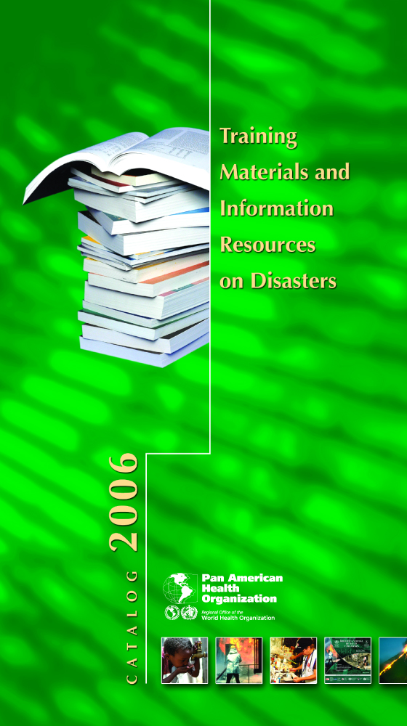 | Catalog 2006. Training materials and information resources for disasters  With the publication of a new print edition of its Disaster Publications Catalog, PAHO/WHO renews its commitment to disseminating, as widely as possible, information on the Organization’s publications, training materials and other information resources on emergencies and disasters. Access to this type of information continues to have tremendous technical and strategic value, both in terms of building capacity among the Region’s health professionals and by advancing political and institutional commitments to disaster reduction. A new version of the online catalog is also being developed.
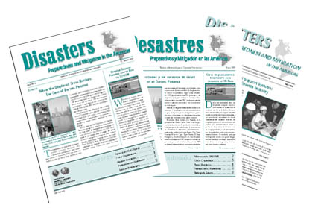 | The newsletter Disasters: Preparedness and Mitigation in the Americas continues to inform more than 27,000 subscribers from around the world about important news, while promoting current technical and policy aspects of disaster management.

.

